KARNATAK LAW SOCIETY’S

GOGTE INSTITUTE OF TECHNOLOGY

UDYAMBAG, BELGAVI-590008

(An Autonomous Institution under Visvesvaraya Technological University Belagavi)

**(APPROVED BY AICTE, NEW DELHI)**



Seminar Report

**TITLE**

**“MATHEMATICS IN NATURE”**

*Submitted in the partial fulfilment for the academic requirement of*

**1st  Semester B.E in**

**MATHEMATICS**

Submitted by

|  |  |
| --- | --- |
| **NAME OF THE CANDIDATE** | **USN** |
| Smruti Sateesh Bhandiwad | GIT201S011-T |
| Shradha Mallikarjun Patil | GIT20CS049-T |
| Omprakash Jat | GIT20IS009-T |
| Basavraj R Duganavar |  |

**TO**

KARNATAK LAW SOCIETY’S

GOGTE INSTITUTE OF TECHNOLOGY

UDYAMBAG, BELAGAVI-590008

(An Autonomous Institution under Visvesvaraya Technological University, Belagavi)

**(APPROVED BY AICTE, NEW DELHI)**

Department of ____________________

 

**CERTIFICATE**

This is to certify that Mr./Ms. …………………………………………. Of I semester and bearing USN ………………………... has satisfactorily completed the course activity (Seminar/Project) in CALCULUS AND LINEAR ALGEBRA course (Course-code : 18MAT11). It can be considered as a bonafide work carried out in partial fulfilment for the academic requirement of I Semester B.E. (……………………………………) prescribed by KLS Gogte Institute of Technology, Belagavi during the academic year 2020- 2021.

The report has been approved as it satisfies the academic requirements in respect of Assignment ( Course activity) prescribed for the said Degree.

Signature of the Faculty Member        Signature of the HOD

Date:

**CONTENTS:**

1. **Introduction**
2. **History of Mathematics**
3. **Golden Ratio**
4. **Fibonacci series**
5. **Fractals**
6. **Conclusion**
7. **References**

**Introduction:**

**Mathematics**, the science of structure, order, and relation that has evolved from elemental practices of counting, measuring, and describing the shapes of objects. It deals with logical reasoning and quantitative calculation, and its development has involved an increasing degree of idealization and abstraction of its subject matter. Since the 17th century, mathematics has been an indispensable adjunct to the physical sciences and technology, and in more recent times it has assumed a similar role in the quantitative aspects of the life sciences.

All mathematical systems (for example, Euclidean geometry) are combinations of sets of axioms and of theorems that can be logically deduced from the axioms. Inquiries into the logical and philosophical basis of mathematics reduce to questions of whether the axioms of a given system ensure its completeness and its consistency.

History of Mathematics:

Mathematics can be called the universal language. It has been developed in different forms across different civilizations throughout the human history but its core and basic concepts have mostly been same.

The word *mathematics* comes from the Ancient Greek term *máthēma* meaning “that which is learnt”. Mathematics has no generally accepted definition. Aristotle defined mathematics as "the science of quantity" and this definition prevailed until the 18th century. Math has helped humans understand the way nature and universe works around them.

In order to clarify the foundations of mathematics, the fields of mathematical logic and set theory were developed. Mathematical logic includes the mathematical study of logic and the applications of formal logic to other areas of mathematics; set theory is the branch of mathematics that studies sets or collections of objects**.**

Brief about important mathematical discoveries

* During their first 300,000 years of existence, human beings explained the phenomena that surrounded them (rains, death, harvest) by turning to the idea of magic and the influence of the gods. And so, it was until around the sixth century B.C. when a revolution began in Ancient Greece in search of the basic principles to understand the observable world.

Pythagoras of Samos and his followers sought to decipher the foundations of reality through numbers, and in doing so they created mathematical abstraction.

He was the first to observe that there is a set of axioms from which all other reasoning can be deduced—through demonstration, which the Pythagoreans established as a basic tool for constructing the framework of mathematics.

Mathematics stopped being a means, to become an end in itself.

* Euclidean geometry:

Written around 300BC, Euclid's work built the foundation for modern mathematics by introducing a set of axioms and proceeding to demonstrate by mathematical rigor a collection of theorems that naturally followed. Covering subjects ranging from algebra to plane geometry (also now known as Euclidean Geometry), Elements remained a cornerstone of mathematical teaching for over 2,000 years following its creation.

* Euler’s number:

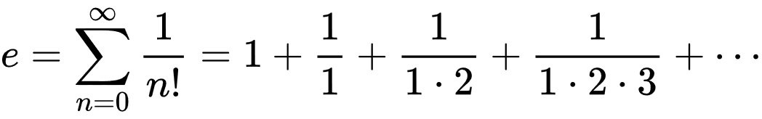

Euler’s identity/number is the base of natural logarithms and is approximately equal to 2.71828…

Take a moment to revel in the fact that with just seven symbols Euler's identity manages to link five of the most important yet seemingly disparate constants in mathematics.

The great physicist Richard Feynman called the identity "one of the most remarkable, almost astounding, formulas in all of mathematics".

* Fast Fourier Transform:

Discrete Fourier Transform (DFT), is a transform first introduced by Fourier in the early 19th century that has the ability to break down signals (like sound waves or wireless signals) into their component frequencies.

Once a signal is transformed into its frequencies it can be manipulated in a much simpler format. For example, a sound decomposed into its frequencies can have its high-frequency noises (which should be unnoticeable) filtered out thereby decreasing the noise and size of the signal without harming the quality. This is just one of a large amount of DFT applications which range from data and image compression (by being able to discard the least noticeable frequencies) to Magnetic Resonance Imaging and many fields in between. But the DFT and its inverse suffer from requiring a largely impractical amount of time to compute. In the 1960s J.W. Tukey and John Cooley invented Fast Fourier Transform (FFT). Their algorithm drastically reduced the time needed to compute the DFT and led to the ubiquity of its application across engineering and mathematical fields.

**Golden Ratio:**

Mathematicians since Euclid have studied the properties of the golden ratio, including its appearance in the dimensions of a regular pentagon and in a golden rectangle, which may be cut into a square and a smaller rectangle with the same aspect ratio. The golden ratio has also been used to analyse the proportions of natural objects as well as man-made systems such as financial markets, in some cases based on dubious fits to data. The golden ratio appears in some patterns in nature, including the spiral arrangement of leaves and other plant parts.

In mathematics, two quantities are in the golden ratio if their ratio is the same as the ratio of their sum to the larger of the two quantities. Expressed algebraically, for quantities *a* and *b* with *a* > *b* > 0,

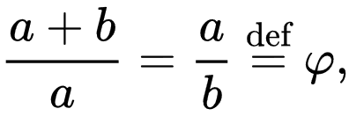

where the Greek letter phi ( {\displaystyle \varphi } or {\displaystyle \phi } ) represents the golden ratio. It is an irrational number that is a solution to the quadratic equation {\displaystyle x^{2}-x-1=0}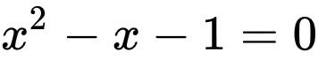 with a value of:

{\displaystyle \varphi ={\frac {1+{\sqrt {5}}}{2}}=1.6180339887\ldots .}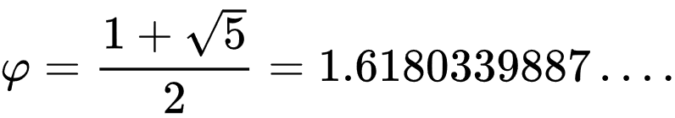

The golden ratio is also called the golden mean or golden section (Latin: *sectio aurea*). Other names include extreme and mean ratio, medial section, divinaproportion (Latin: proportio divina) divine section (Latin: sectio divina), golden proportion, golden cut, and golden number.

**Geometry of the Golden ratio:**

The Golden Ratio is also found in geometry, appearing in basic constructions of an equilateral triangle, square and pentagon placed inside a circle, as well as in more complex three-dimensional solids such as dodecahedrons, icosahedrons and “Bucky balls,” which were named for Buckminster Fuller and are the basis for the shapes of both Carbon 60 and soccer balls.

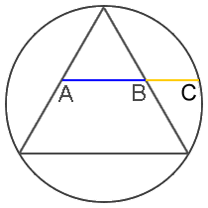 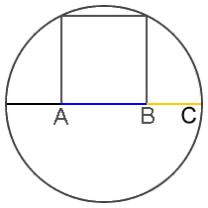

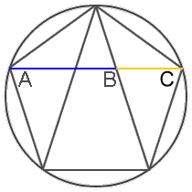

GOLDEN RATIO IN NATURE:

* Faces:

Faces, both human and nonhuman, abound with examples of the Golden Ratio. The mouth and nose are each positioned at golden sections of the distance between the eyes and the bottom of the chin. Similar proportions can been seen from the side, and even the eye and ear itself (which follows along a spiral).

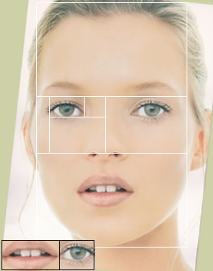

It's worth noting that every person's body is different, but that averages across populations tend towards phi. It has also been said that the more closely our proportions adhere to phi, the more "attractive" those traits are perceived. As an example, the most "beautiful" smiles are those in which central incisors are 1.618 wider than the lateral incisors, which are 1.618 wider than canines, and so on. It's quite possible that, from an evo-psych perspective, that we are primed to like physical forms that adhere to the golden ratio — a potential indicator of reproductive fitness and health.

* DNA Molecule:

Even the microscopic realm is not immune to Fibonacci. The DNA molecule measures 34 angstroms long by 21 angstroms wide for each full cycle of its double helix spiral. These numbers, 34 and 21, are numbers in the Fibonacci series, and their ratio 1.6190476 closely approximates Phi, 1.6180339(golden ratio).

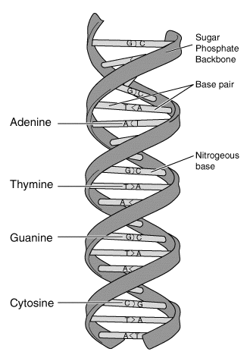

[This Photo](https://en.wikipedia.org/wiki/Molecular_Structure_of_Nucleic_Acids:_A_Structure_for_Deoxyribose_Nucleic_Acid) by Unknown Author is licensed under [CC BY-SA](https://creativecommons.org/licenses/by-sa/3.0/)

* Shells:

The unique properties of the Golden Rectangle provides another example. This shape, a rectangle in which the ratio of the sides a/b is equal to the golden mean (phi), can result in a nesting process that can be repeated into infinity — and which takes on the form of a spiral. It's call the logarithmic spiral, and it abounds in nature.

**Fibonacci Series:**

In mathematics, the Fibonacci numbers, commonly denoted *Fn*, form a sequence, called the Fibonacci sequence, such that each number is the sum of the two preceding ones, starting from 0 and 1. That is,

 and 

for n>1.

Hence the beginning of the sequence is

0,1,1,2,3,5,8,13,21,34,55,89,144…...

**Fibonacci series in Nature:**

1. Flower Petals

The number of petals in a flower consistently follows the Fibonacci sequence. Famous examples include the lily, which has three petals, buttercups, which have five (pictured at left), the chicory's 21, the daisy's 34, and so on. Phi appears in petals on account of the ideal packing arrangement as selected by Darwinian processes; each petal is placed at 0.618034 per turn (out of a 360° circle) allowing for the best possible exposure to sunlight and other factors.

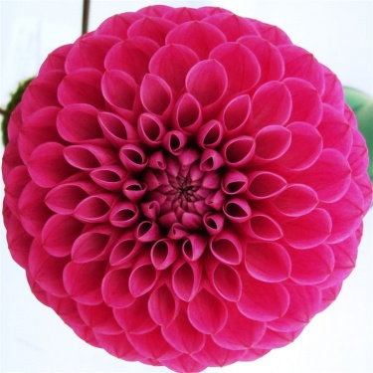

2.Seed heads:

#### 

The head of a flower is also subject to Fibonaccian processes. Typically, seeds are produced at the center, and then migrate towards the outside to fill all the space. Sunflowers provide a great example of these spiraling patterns.

In some cases, the seed heads are so tightly packed that total number can get quite high — as many as 144 or more. And when counting these spirals, the total tends to match a Fibonacci number. Interestingly, a highly irrational number is required to optimize filling (namely one that will not be well represented by a fraction). Phi fits the bill rather nicely.

#### 3. Spiral Galaxies:

#### Not surprisingly, spiral galaxies also follow the familiar Fibonacci pattern. The Milky Way has several spiral arms, each of them a logarithmic spiral of about 12 degrees. As an interesting aside, spiral galaxies appear to defy Newtonian physics. As early as 1925, astronomers realized that, since the angular speed of rotation of the galactic disk varies with distance from the center, the radial arms should become curved as galaxies rotate. Subsequently, after a few rotations, spiral arms should start to wind around a galaxy. But they don't — hence the so-called winding problem. The stars on the outside, it would seem, move at a velocity higher than expected — a unique trait of the cosmos that helps preserve its shape.

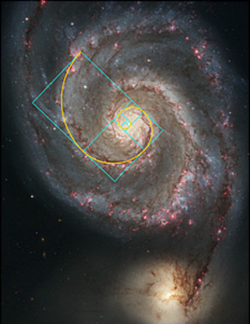

**Fractals:**

Fractal geometry is a field of maths born in the 1970’s and mainly developed by Benoit Mandelbrot. It’s called the Mandelbrot Set and is an example of a fractal shape.

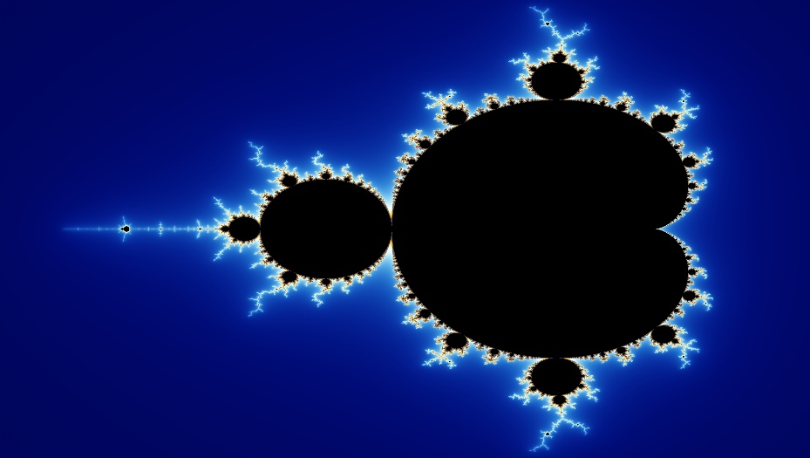

Fractal geometry is no different from the classical geometry that we learnt in school, the difference being that the shapes that we drew were smooth like say a circle or a triangle while in fractal geometry the shapes are rough and infinitely complex.

A fractal is a shape that is similar to the whole in some way. This is the simplified definition of a fractal given by Mandelbrot.

HOW ARE FRACTALS DIFFERENT FROM THE DEFINITE GEOMETRIC FIGURES:

The main difference lies in their scaling. If the edge length of a polygon is doubled, the area of the polygon is increased by four times which is 2(the ratio of final length to the initial length) to the power 2(the dimension in which the polygon lies). Similarly, if the radius of a sphere is doubled, the volume of the sphere increases by 8 times which is essentially 2(the ratio of the final length of radius to the initial length of radius) to the power 3(The dimension in which the sphere lies).

But if the fractal’s one-dimensional lengths are all doubled, the spatial content increases by a power by a number that is not essentially an integer.

The consensus among mathematicians is that theoretical fractals are infinitely self-similar, iterated, and detailed mathematical constructs having fractal dimensions, of which many examples have been formulated and studied. Fractals are not limited to geometric patterns, but can also describe processes in time. Fractal patterns with various degrees of

self-similarity have been rendered or studied in images, structures, and sounds and found in nature, technology, art, architecture and law. Fractals are of particular relevance in the field of chaos theory because the graphs of most chaotic processes are fractals. Many real and model networks have been found to have fractal features such as self-similarity.

* Methods of generating fractals

FRACTALS IN NATURE:

Fractals can be seen everywhere around us. We can find fractals in our circulatory and respiratory systems, the trees that are around us (the branching of the trees and also the venation in the leaves), etc.

* Fractals in trees and leaves and plants:

Fractals are seen in the branches of trees from the way a tree grows limbs. The main trunk of the tree is the origin point for the Fractal and each set of branches that grow off of that main trunk subsequently have their own branches that continue to grow and have branches of their own. Eventually the branches become small enough they become twigs, and these twigs will eventually grow into bigger branches and have twigs of their own. This cycle creates an “infinite” pattern of tree branches. Each branch of the tree resembles a smaller scale version of the whole shape.



[This Photo](https://commons.wikimedia.org/wiki/File:Branched_Tree_(1).JPG) by Unknown Author is licensed under [CC BY-SA](https://creativecommons.org/licenses/by-sa/3.0/)

In leaves:

The midrib of the leaf becomes the starting point of the fractal. Further the veins of the leaves go on branching from one to other thus creating an infinite pattern.

Similarly, in ferns also fractal patterns can be observed. They are essentially made of the same iterating structure.

Another example is of a type of broccoli called Romanesco. This type of broccoli has an incredible structure of spires which emanate from a single source that in turn have their own spires which continue on to the tip of the plant.

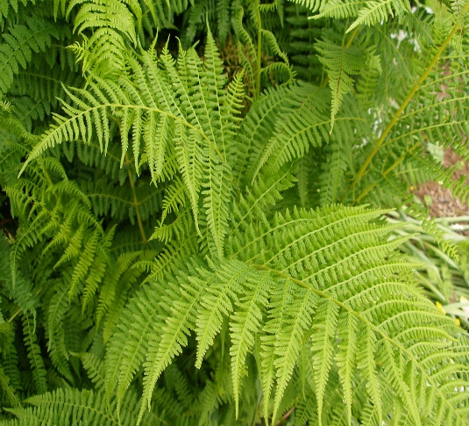

[This Photo](http://www.flickr.com/photos/quinet/8617653251/) by Unknown Author is licensed under [CC BY](https://creativecommons.org/licenses/by/3.0/)

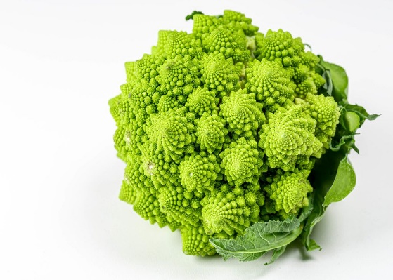

[This Photo](https://foto.wuestenigel.com/romanesco-broccoli-cabbage-or-roman-cauliflower-on-white-background-flip-2020/) by Unknown Author is licensed under [CC BY](https://creativecommons.org/licenses/by/3.0/)

The smallest unit in each of these cases resembles the whole structure.

* Fractals in animal bodies:

We can observe fractals in animal bodies. A very good example for this is the respiratory system. The respiratory system begins with a trachea and then goes on to branch into a network of fine-grained cavities.



The primary bronchi undergoes division to form secondary and tertiary bronchi which further divide to form primary, secondary and tertiary bronchioles.

* Koch Snowflake:

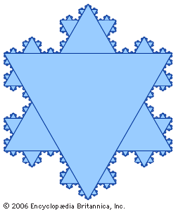

The Koch snowflake is a fractal curve and one of the earliest fractals to be described.

References

* <https://www.bbvaopenmind.com/en/science/mathematics/when-magic-gave-way-to-numbers/>
* <https://www.mic.com/articles/29778/pi-day-5-greatest-mathematical-discoveries-in-history>
* <https://www.britannica.com/science/mathematics>
* <https://www.mathnasium.com/examples-of-the-golden-ratio-in-nature>
* <https://iternal.us/what-is-a-fractal/>
* <https://en.wikipedia.org/wiki/Fractal#Natural_phenomena_with_fractal_features>

{\displaystyle {\frac {a+b}{a}}={\frac {a}{b}}\ {\stackrel {\text{def}}{=}}\ \varphi ,}